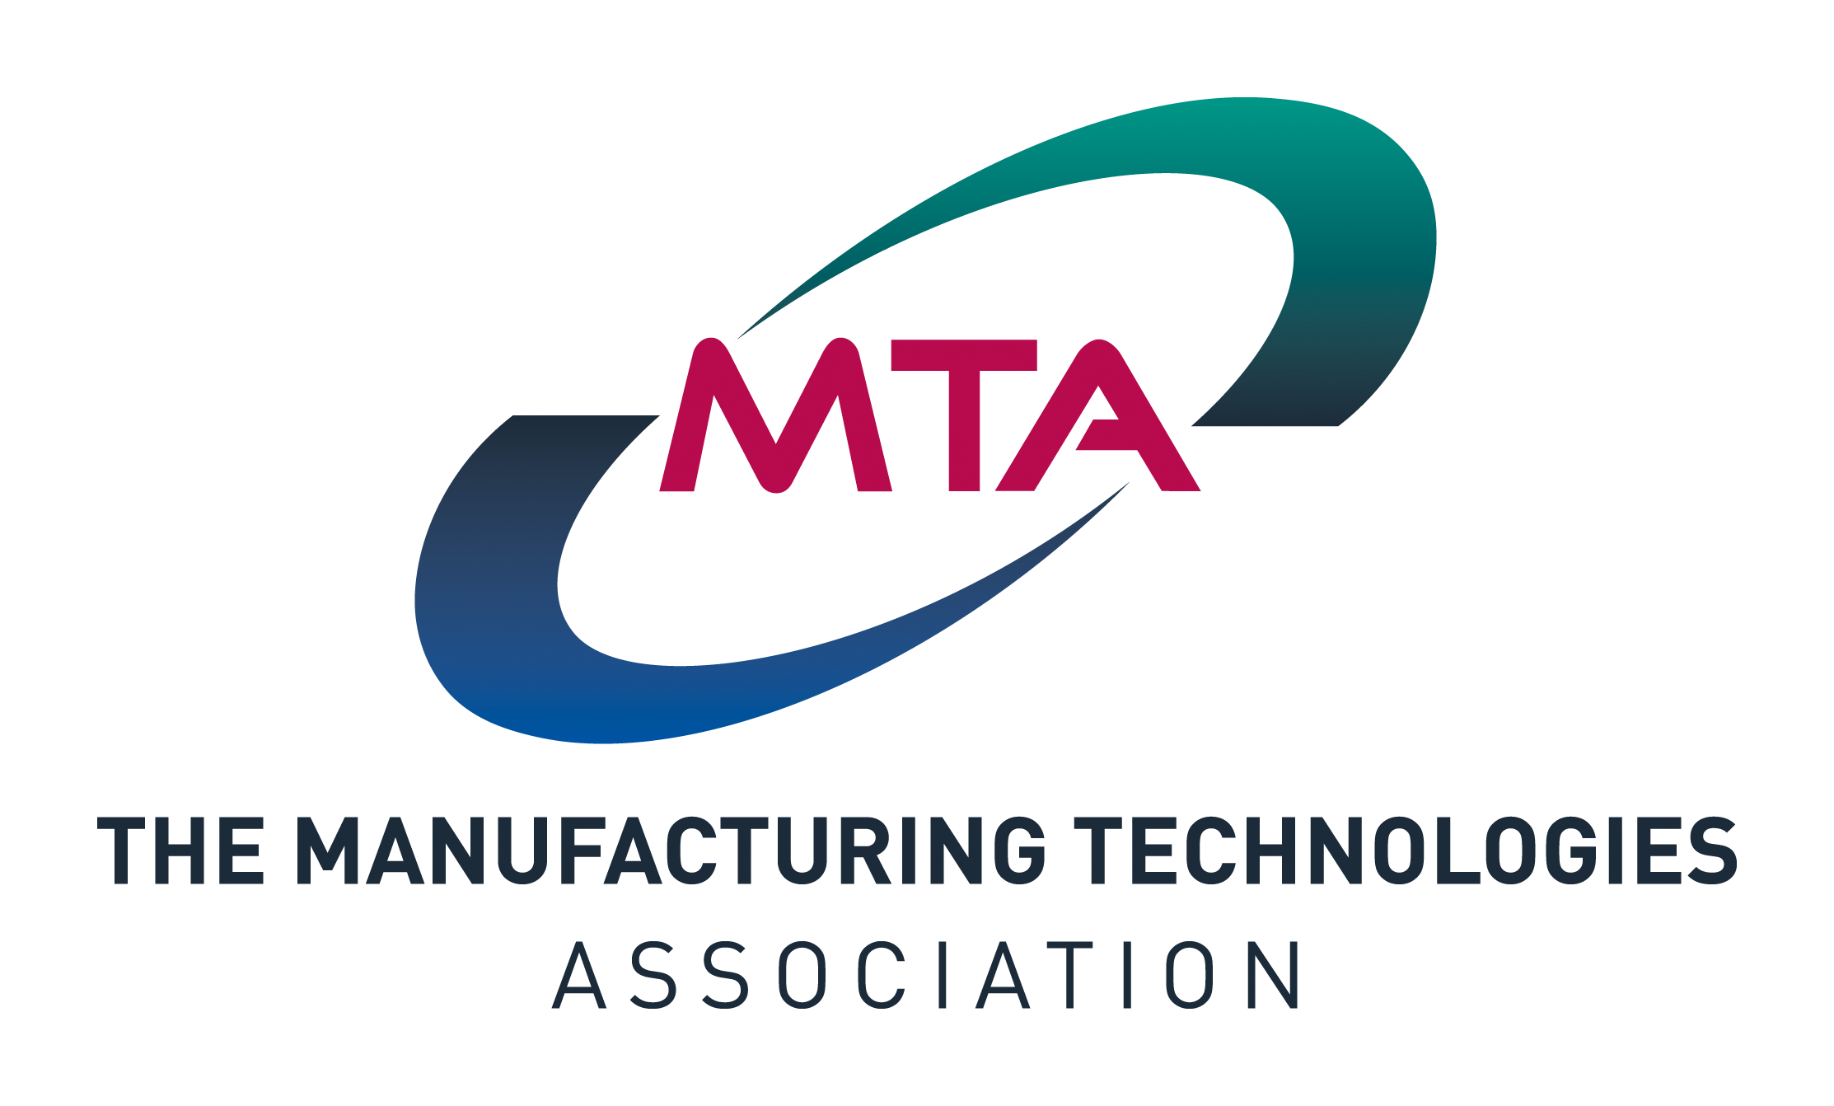 | Instruction to your Bank or Building  Society to pay by Direct Debit

Please fill in the whole form and send it to:  The Manufacturing Technologies Association  62 Bayswater Rd, London W2 3PS  Name and full postal address of your Bank or Building Society
  Service user number
  Reference
  M | A | C | H | -
  Instruction to your Bank or Building Society
  Please pay The Manufacturing Technologies Association Direct Debits from the account detailed in this Instruction subject to the safeguards assured by the Direct Debit Guarantee. I understand that this Instruction may remain with The Manufacturing Technologies Association and, if so, details will be passed electronically to my Bank/Building Society.
  Signature(s)
  Date
To: The Manager | Bank/building society

Address

Postcode

Name(s) of Account Holder(s)
Bank/Building Society account number
Branch Sort Code
 |  |  |  |  |  |  |  |  |  | DDI 8 5/15

Banks and Building Societies may not accept Direct Debit Instructions for some types of account.
This guarantee should be detached and retained by the payer.

The Direct Debit Guarantee
- This Guarantee is offered by all banks and building societies that accept instructions to pay Direct Debits  - If there are any changes to the amount, date or frequency of your Direct Debit The Manufacturing Technologies Association will notify you 7 working days in advance of your account being debited or as otherwise agreed. If you request The Manufacturing Technologies Association to collect a payment, confirmation of the amount and date will be given to you at the time of the request |  |  |  |  |  |  |  |  |  | - If an error is made in the payment of your Direct Debit, by The Manufacturing Technologies Association or your bank or building society, you are entitled to a full and immediate refund of the amount paid from your bank or building society  – If you receive a refund you are not entitled to, you must pay it back when The Manufacturing Technologies Association asks you to  - You can cancel a Direct Debit at any time by simply contacting your bank or building society. Written confirmation may be required. Please also notify us.

